1. How to create a master-worker spark topology based in vagrant

To create a spark cluster it's necessary to launch a virtual machine for each node in the cluster, in that case you will create a topology with only one worker node, so it is only need two virtual machines.
Each node in the cluster must have the following programs installed:

- Java version 7 or 8.
- OpenSSH, for the communicate between the master node and the worker nodes. This program only needs be installed in the worker nodes.
- Pre-built Apache Spark for Hadoop.

It's not necessary to be installing the programs in each node, you can create a Vagrant Box to cloning all nodes you need.

Steps to follow:

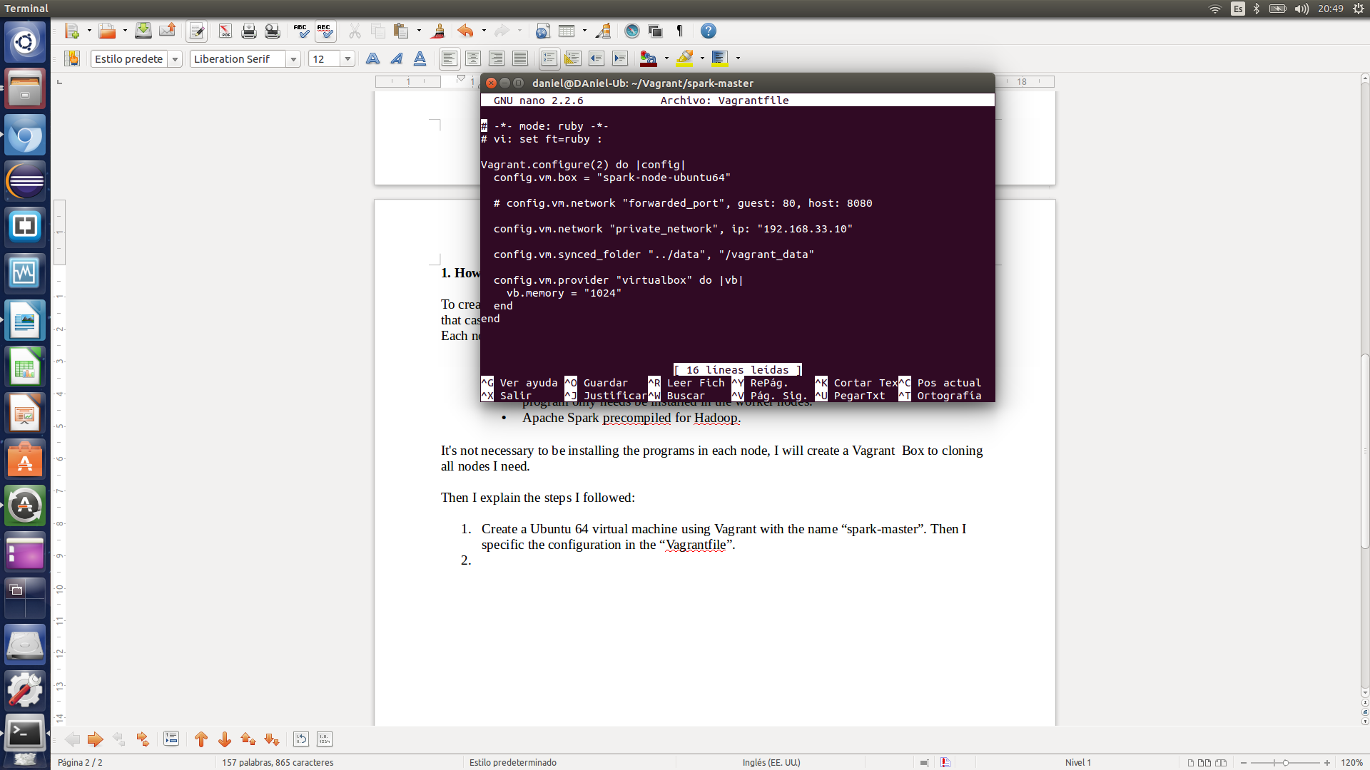
- Create a Ubuntu 64 virtual machine using Vagrant with the name “spark-master”. Then you specify the configuration in the “Vagrantfile”.

Steps 2 to 4, will be made within the virtual machine.

- Install Oracle Java 8:

-sudo apt-add-repository ppa:webupd8team/java
-sudo apt-get update
-sudo apt-get install oracle-java8-installer

- Install OpenSSH:

-sudo apt-get install openssh-server

This program is not necessary in the master node, but I installed it because I will clone this machine to create the worker nodes.

- Install pre-built Apache Spark for Hadoop downloading from the Spark website: https://spark.apache.org/downloads.html
After it is descompressed in the following path: home/vagrant

- In this way it's necessary stop the virtual machine to create a Vagrant Box and clone it after:

-vagrant package
-vagrant box add spark-node-ubuntu64 /Vagrant/spark-master/package.box

- Start the master node VM and then create the worker node VM with the new box. When you create a new node you need specify the private IP in the “Vagrantfile” to communicate with the master node, as in the first step.

- Now it's necessary to configure the connection between the master node and the worker node, generating a RSA key in the master and copy it in the worker.

In the master:
-ssh-keygen
-ssh-copy-id -i ~/.ssh/id_rsa.pub vagrant@”worker_ip”

- In this step you will configure Apache Spark. Inside the “conf” folder is a file called “slaves.template”, which will rename to “slaves”. This file contains the IP addresses of the slave nodes (workers), so we will comment all lines with '#' and add the IP of our worker node VM to finally looks like this:
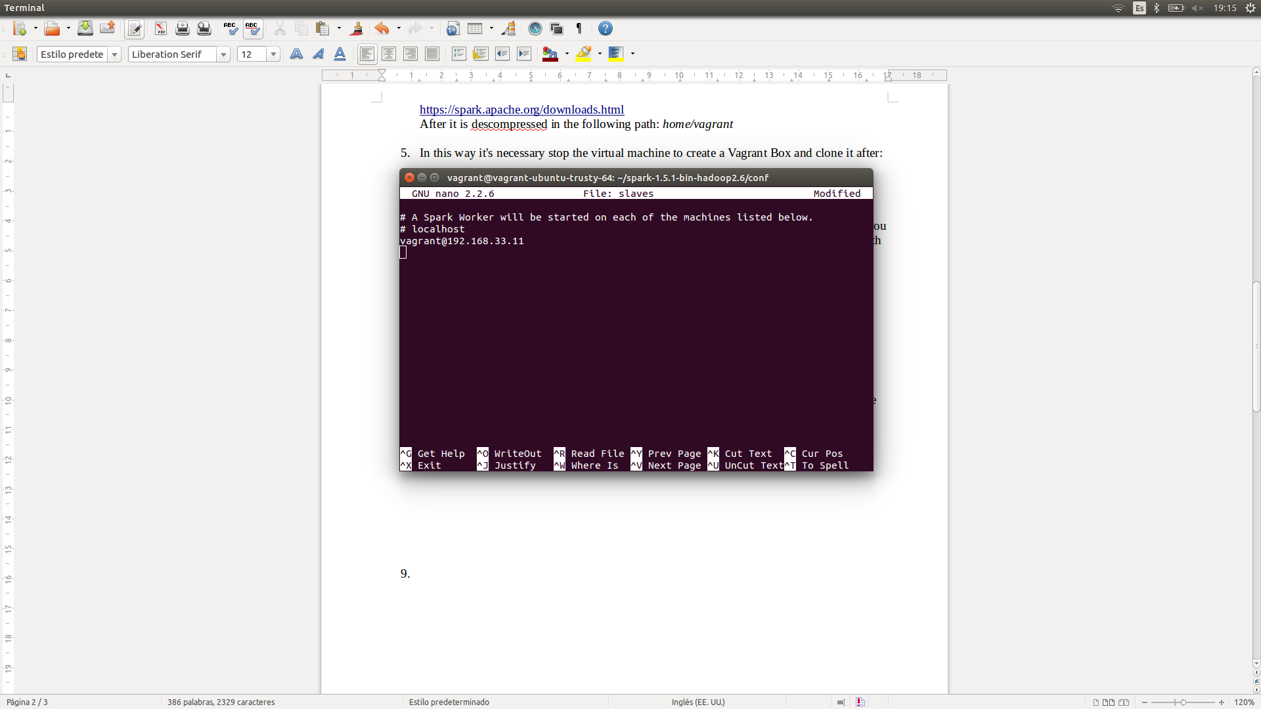

In the same folder is a file called “spark-env.sh.template”, which will rename to “spark- env.sh”. Add the following lines of configuration:

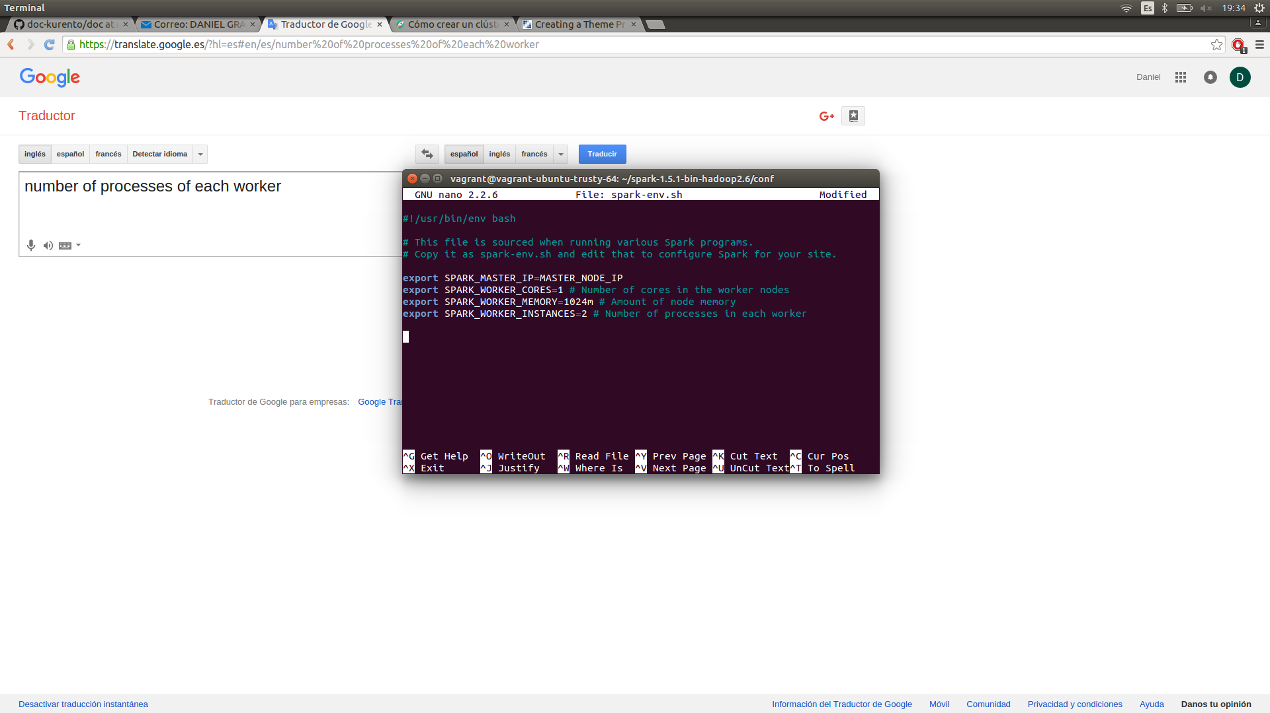

Copy these two files in the same folder into the worker node.

- In the “sbin” folder, you have to execute the ./start-master.sh exe in the master node VM, and the ./start-slave.sh in the worker node VM. You need root permissions so use the “sudo” command.

In the master:
-sudo ./start-master.sh

In the worker:
-sudo ./start-slave.sh

If all works fine, the cluster should be on. To check it you can access to the web panel at “MASTER_NODE_IP:8080”.

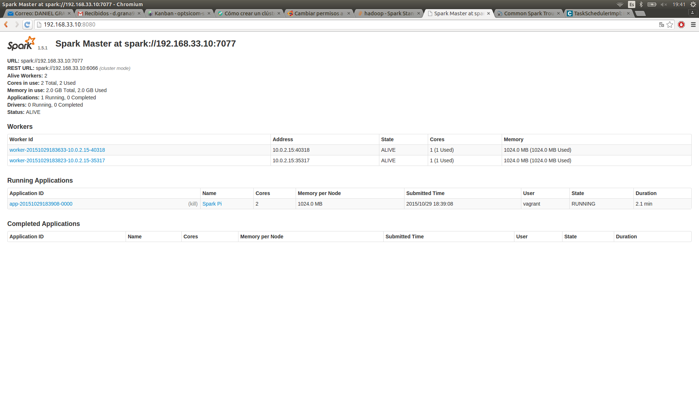

2. How to create a master-several workers spark topology based in vagrant

To create a spark cluster with several workers, only need repeat the steps six to eight for each node in the cluster, but the “spark-env.sh” and “slaves” files will be the same in each node.
The only difference is that now the "slaves" file instead of having the IP of a single node, the file will have the IP of all workers nodes.

Now to run the cluster you have to follow step nine and go running nodes one by one.

